**Name: Ziad ahmed rezk awad Abd el Nabi**

**B.N: 364**

**Date: 28/5/2020**

**Topic:** **Computer Architecture**

**Github link:** <https://github.com/Ziad-Rezk/Computer-Architecture->

**Github page:** https://ziad-rezk.github.io/Computer-Architecture-/

**Application brief**

In computer engineering, computer architecture is a set of rules and methods that describe the functionality, organization, and implementation of computer systems. Some definitions of architecture define it as describing the capabilities and programming model of a computer but not a particular implementation. In other definitions computer architecture involves instruction set architecture design, microarchitecture design, logic design, and implementation. There are three categories of computer architecture:

1. System Design: This includes all hardware components in the system, including data processors aside from the CPU, such as the graphics processing unit and direct memory access. It also includes memory controllers, data paths and miscellaneous things like multiprocessing and virtualization.
2. Instruction Set Architecture (ISA): This is the embedded programming language of the central processing unit. It defines the CPU's functions and capabilities based on what programming it can perform or process. This includes the word size, processor register types, memory addressing modes, data formats and the instruction set that programmers use.
3. Microarchitecture: Otherwise known as computer organization, this type of architecture defines the data paths, data processing and storage elements, as well as how they should be implemented in the ISA.

**Some applications:** the exact form of a computer system depends on the constraints and goals. Computer architectures usually trade off standards, power versus performance, cost, memory capacity, latency (latency is the amount of time that it takes for information from one node to travel to the source) and throughput. Sometimes other considerations, such as features, size, weight, reliability, and expandability are also factors. the most common scheme does an in-depth power analysis and figures out how to keep power consumption low while maintaining adequate performance.

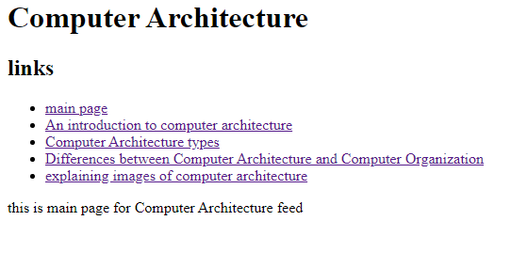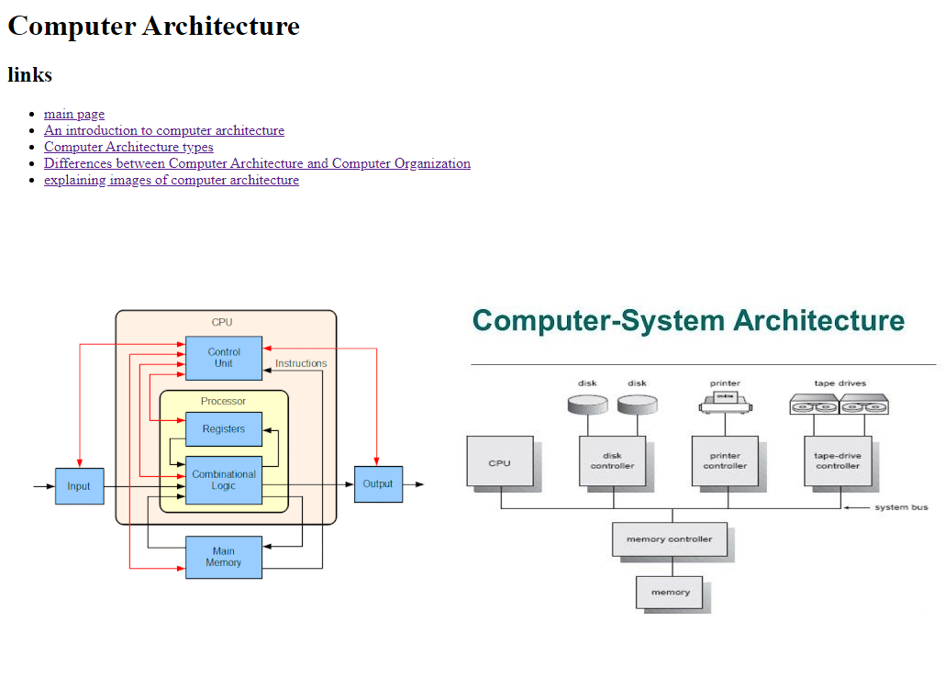**Screenshots:**

**Source code:**

